**FALL 2023 GRADUATE SCHOOL COMMENCEMENT**

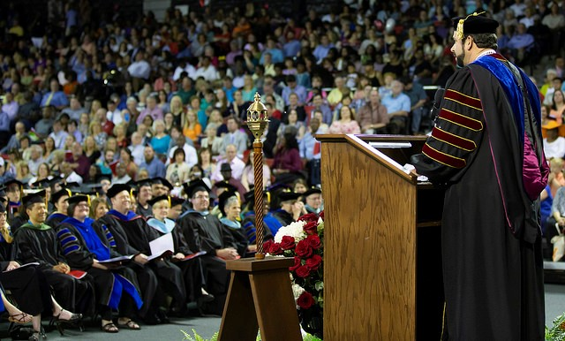

**CONGRATULATIONS, Graduates!! This is a huge accomplishment, and we are so excited to celebrate this milestone with you!!**

Fall 2023 Graduate School Commencement is scheduled for:

**5:00 PM**

**Friday, December 8th**

**in VSU’S PE Complex**

Students (and faculty hooding the Doctoral Candidates) should **arrive no later than 4:00 pm** to check in and lineup in the **P.E. Complex 2nd floor Mezzanine level**at the corners of Baytree Road and Sustella Avenue.

Students receiving their Masters' or Education Specialist degrees will process already hooded. [Tips for Graduation Regalia Wear](https://www.valdosta.edu/academics/graduate-school/documents/graduate-regalia-wear-tips.pdf). **Doctoral Candidates will be hooded on stage. Please view the Hooding Instructions by clicking the video below:**

|  |  |
| --- | --- |
| [https://i.ytimg.com/vi/vz9FP7y6Aso/maxresdefault.jpg](https://nam12.safelinks.protection.outlook.com/?url=https%3A%2F%2Fyoutu.be%2Fvz9FP7y6Aso%3Ft%3D48&data=05%7C01%7Cdjdevane%40valdosta.edu%7Cf9de3d4bd0a34964ee1508da222fa7a0%7C25a5d3408abc4053b4bddc1213280353%7C0%7C0%7C637859885316595922%7CUnknown%7CTWFpbGZsb3d8eyJWIjoiMC4wLjAwMDAiLCJQIjoiV2luMzIiLCJBTiI6Ik1haWwiLCJXVCI6Mn0%3D%7C3000%7C%7C%7C&sdata=HaHuwUAz7n8se70KB4%2FR%2BH2o1e%2FVnX1scyv1%2FmwTdFE%3D&reserved=0) | [How to Correctly Put on Your Graduation Hood | Valdosta State University](https://nam12.safelinks.protection.outlook.com/?url=https%3A%2F%2Fyoutu.be%2Fvz9FP7y6Aso%3Ft%3D48&data=05%7C01%7Cdjdevane%40valdosta.edu%7Cf9de3d4bd0a34964ee1508da222fa7a0%7C25a5d3408abc4053b4bddc1213280353%7C0%7C0%7C637859885316595922%7CUnknown%7CTWFpbGZsb3d8eyJWIjoiMC4wLjAwMDAiLCJQIjoiV2luMzIiLCJBTiI6Ik1haWwiLCJXVCI6Mn0%3D%7C3000%7C%7C%7C&sdata=HaHuwUAz7n8se70KB4%2FR%2BH2o1e%2FVnX1scyv1%2FmwTdFE%3D&reserved=0)  This short but helpful video provides a tutorial explaining how to correctly put on and wear the Master's Hood. Congratulations candidates!#ValdostaStateUniv...  youtu.be |

If you plan on walking in the Graduate School Commencement ceremony, you should have submitted your graduation application with notation you will be attending commencement.

Once you arrive to the Complex, go to the 2nd floor Mezzanine, find your table, and pick up your card that will have your name to be read as you walk across the stage. Please hang on to the card and bring it with you as you are escorted to the stage during the ceremony.

There will be a live stream for family and friends who are unable to attend commencement. Click the link below <https://www.valdosta.edu/academics/graduate-school/commencement.php> scroll down to where you see

**“Watch the commencement live stream Here”.** The link will be live 30 minutes before the ceremony starts.

**We are so excited to celebrate this momentous occasion with you!!** **Blaze will be onsite as well for fun pre-commencement photos. See you Friday, December 8th at 4pm!!**