April 15, 2016

President’s End-of-Year Report

70/80 Task Force on Retention
Valdosta State University
Executive Summary of Major Findings and Recommendations
The President’s Charge: The 70/80 Task Force on Retention is charged with progressively increasing the overall retention rate of Valdosta State University towards, and above, 80% through a variety of pragmatic and cultural transformations.
70/80 Task Force Vision: Our aim is to cultivate an inclusive, transparent, cultural transformation of the VSU community to more clearly reflect the student-centered, VSYou experience.

Background

Convened in Fall 2015, the 70/80 Task Force met as a full committee 10 times from October to April. Additionally, subcommittees met frequently throughout the spring to formulate recommendations.

Committee members are as follows:
Co-chairs: (December to April) Greg Harrell, Professor, and Lee Grimes, Assistant Professor
Chair: (October to December) Travis York, Assistant Professor
70/80 Task Force Members: Thomas Macera (Head Softball Coach), Shannon McGee (Director of Auxiliary Services), Carla Jordan (Assistant Director, Employer Relations and Experiential Learning), Brian Roberts (Assistant Director, Student Life), Chere Peguesse (Director, Student Success Center), John Crawford (VP of Advancement & CEO of VSU Foundation), Sage Archer (Director of Event Services), Christy Yates (Director of Operations and Special Projects), Shani Wilfred (Associate Professor), Tee Mitchell (Director of Admissions), Brian Gerber (Interim Provost and Vice President for Academic Affairs), Barrie Fitzgerald (Director of Institutional Research), Melinda Cutchens (Executive Administrative Specialist), Alicia Roberson (Director, Centralized Advising), Kimberly Tanner (Director, Access Office), Abbigail Edwards (BSED Middle Grades Education Student)

Task Force members, representing programs campus-wide, have gathered and analyzed a number of data sets, information from student focus groups, feedback from faculty, scholarly research on best practices for student retention, and information about how peer institutions have addressed retention and graduation.

From this research, we believe a university-wide, cohesive plan to improve student retention and graduation will clarify and connect a number of processes and unify both successful and emerging programs and practices.

Recommendations

The Task Force has identified five areas of concentration:
- Course Innovations guided by the John Gardner Institute’s G2C Project (JNGI/G2C)
- Redefining Advising
- Student Services and Engagement
- Strategic Message
- Liaisons to Academic Ambassadors

Sub-committees were formed around each of these five areas. The following sections provide summarized recommendations from each sub-committee:

Course Innovations
- John N. Gardner Institute (JNGI) Gateways to Completion, Phases 1-3
- Intentional and frequent transparent communication regarding retention efforts via course innovations (e.g., JNGI).
- Cultural shift to focusing on service (e.g., student success) in regard to faculty evaluation criteria
- Incentives that promote investment by faculty and staff in the culture of VSU
(See Appendix A for additional information about the Gateways to Completion Initiative and detailed recommendations from the Course Innovations Subcommittee.)

- Redefining Advising
  - Centralized coordination of academic advising and associated activities within Academic Affairs
  - Identify campus-wide leadership for academic advising
  - Establish an Academic Advising Council with Academic and Student Affairs stakeholders as members
  - Bring consistency to advisor roles, responsibilities, and professional development
  - Use and market available technology
  - Develop a baseline assessment from which to benchmark improvement
  - Increase Success Portal usage
(See Appendix B for additional information including recommendations from NACADA on Advising at VSU.)

- Student Services and Engagement
- Revitalize efforts within Student Affairs to bridge gaps between student life and retention
- Implementation of a Campus Traditions Committee
- Creation of a Center for Student Involvement department within Student Affairs
- Implementation of a Greek Life Revitalization Committee
- Implementation of mandated Freshman Seminar/First Year Experience as part of curriculum
- Revamp Orientation Programs to include campus life activities
- Increase faculty and staff engagement with students
  - Creation of a Faculty Liaison Program with Athletics
  - Implement Faculty/Staff Engagement Initiative
- Implement guidelines for course materials and textbooks
(See Appendix C for additional details from the Student Services and Engagement Subcommittee.)

- Strategic Message
- Technological Innovations
  - FAQs App or Icon
  - User-Friendly Website
  - Virtual Images
  - Event TV Screens
  - 70/80 Task Force Website
- Value-Added
  - Value of Student Services
  - Value of Degree Right Out of the Box
  - VSU on the Map
  - Community Engagement in the broader Valdosta community
  - Safety
See Appendix D for additional information from the Strategic Message Subcommittee.

- Liaisons to Academic Ambassadors
- Advising and Retention Liaison in Academic Affairs
- Deans
- Department Heads
- Departmental Retention Liaisons

Conclusion

Consideration for Creating a Director of Student Retention Position
The Student Services and Engagement Subcommittee believes there are many components related to retention regarding both academics and student life that must be addressed at VSU to move the needle closer to 80%. Through conversations and brainstorming sessions, it has become clear that concerted and comprehensive efforts are needed by various campus departments to attain the desirable outcomes. Perhaps it should be considered to create a position within Enrollment Services that heads retention efforts on an ongoing basis and keeps all of the campus pieces affecting retention connected. This position should work closely with an Advising and Retention Liaison in Academic Affairs to implement, coordinate, and monitor a comprehensive retention plan.

Appendix A
Course Innovations Subcommittee

John N. Gardner Institute and Gateways to Completion

Gateways to Completion (G2C) is designed to create and implement an evidence-based plan for improving teaching, learning, and success in historically high-failure rate courses. Success in foundation level courses, such as accounting, math, chemistry, biology and writing and rhetoric is a direct predictor of retention. Gateways to Completion (G2C) provides institutions with assistance on the processes, guidance, and tools to support redesign of lower division and/or developmental level courses.

Developed with the insight of a distinguished national Advisory Committee, the comprehensive G2C approach provides a structured, evidence-based course self-study process with advice and support from the nation’s leader in higher education student success.

Since fall of 2013, 13 institutions are working to reduce the unacceptable rates of DWFI grades in gateway courses through G2C.

Valdosta State University chose in its first phase of G2C to work with faculty in the following courses for the implementation of these innovations: HIST 2112, MATH 1111, ENGL 2113, CHEM 1211, and BIOL 1107.

70/80 Task Force Course Innovations Subcommittee Recommendations*

- Intentional and frequent transparent communication
  - An information campaign (digital, print, audio/visual) for faculty and staff which is designed to communicate the focus of the 70/80 task force: cultural transformation.
  - The holding of town hall-like meetings, open to the entire VSU community, which present a holistic overview of the focus areas (subcommittees) of the task force and the relationship between those focus areas and cultural transformation at VSU.
  - The inclusion of periodic updates from the 70/80 task force on some of the findings and initiatives that have resulted from its efforts in the president’s newsletter.
  - Target information sessions for faculty that define the following:
    - course innovations
    - JNGI initiative
      - Course selection process
      - Role of JNGI
      - JNGI course transformation initiative impact on departments
      - Intended uses of JNGI findings
    - Intended uses of the success portal
      - Articulation of what it is
        - Tool to ensure students are successful in all walks of life
        - Tool to ensure “qualified students” do not leave VSU because of issues that were in our power to address
        - Tool to catch early warning signs of potential DFWI results for students
        - Tool to promote engagement in the VSU community
        - Tool for collaboration between faculty and staff to ensure proper channels have the information needed to assist students.
        - Tool for documenting student contact and efforts to assist students in being successful
        - Tool for advising online students and trying to engage them in the VSU community.
      - Confirmation of what it is not
        - …faculty blaming mechanism
        - …additional busy work
        - …lowering of academic standards
        - ….removal of student responsibility
      - Specification of faculty expectation
        - Required or optional
        - Part of evaluation or expected service
      - Specification of impact on students
        - Permit or temporary record
        - Who has access to content
      - Specifications of mechanisms for obtaining faculty input regarding usability and needed improvements.

- Cultural shift to focusing on service in regard to faculty merit criteria
  - a revisit of the University promotion and tenure document, in which, the University’s commitment to service (i.e., student success) is reflected in the weight given to service in the promotion and tenure document.
    - This recommendation would also include that colleges and related units also revisit their promotion and tenure documents to reflect the university’s commitment to acknowledging and awarding service.
    - The current evaluation criteria for promotion and tenure of faculty include teaching, professional development, and service. Service is given the least weight in many promotion and tenure documents. Thus, many faculty culturally have been taught that it is “publish or perish.”
    - In order to facilitate a cultural transformation at VSU that reflects the type of learning community in which everyone is concerned with student success, this inconsistency in University documents and the subterranean messages it generates needs to be addressed by aligning the University documents with the cultural values of the University.
  - Development of a course innovation showcase in which faculty are able, annually or each semester, to be informed about course transformations by their peers.
  - Development of an institutional award for course innovations which is either awarded by faculty and/or a joint committee of faculty, staff, and students.

- Initiatives to promote cultivation of a sense of VSU community
  - The introduction of incentives that promote investment by faculty and staff in the culture of VSU.
    - Such incentives could include significantly discounted VSU business casual and business paraphernalia such as polos and dress shirts in which faculty and staff can purchase and can wear on days such as Blazer Friday.
    - The provision of VSU paraphernalia such as cardholders, key rings, water bottles, pins, portfolio folders, etc., at the beginning and/or end of each academic semester or year, as a symbolic reminder that we are VSYou.
    - An increased frequency of faculty and staff social events which allow faculty and staff to come together to get to know each other and to learn more about how interconnected each of their roles are in sustaining VSU.

* Informed by formal and informal conversations with faculty and discussions at the 70/80 task force meetings.

Academic Advising Review
Consultant Visit Report

VALDOSTA STATE UNIVERSITY February 9-11, 2016

Susan Campbell, Ed.D.
NORTHEASTERN UNIVERSITY

Karen Sullivan-Vance, Ed.M.
WESTERN OREGON UNIVERSITY

Prepared for Valdosta State University, February 9-11, 2016

At the invitation of Valdosta State University, a NACADA Consultant team was identified to conduct a review of the university’s academic advising program. This review was intended to provide guidance to campus leaders regarding the organization, delivery, and support of academic advising. The NACADA Consultant Team included:

Dr. Susan Campbell
Senior Advisor to the Dean for Advising & Career Planning Lowell Institute School - College of Professional Studies Northeastern University

Ms. Karen Sullivan-Vance
Director of the Academic Advising and Learning Center
Western Oregon University

“Academic Advising is the only structured activity on the campus in which all students have the opportunity for one-to-one interaction with a concerned representative of the institution.”

Wes Habley, 2004

Introduction

The role and importance of academic advising in supporting student success has changed significantly over the last few years, as has who is involved in its delivery. Once primarily the purview of faculty members, many institutions and, in particular, public universities, now also have professional staff members who serve as academic advisors. The importance of academic advising to student persistence and success in college continues to be documented in the research such that academic advising is increasingly considered central to any institution’s retention strategy.

Whether faculty or professional, advisors play an integral role in the success of students by inviting them to become part of the community of scholars that is the university, and mentoring them in their interactions with faculty members, administrators, staff members and peers. Advisors help students navigate complex systems, facilitate the exploration of life and career goals, and challenge students to think critically about their experiences with the curriculum and co-curriculum. Advisors demystify the curriculum for students, explaining connections that are often implied, but seldom clearly explained.
Advisors teach students how to ask and reflect on the tough questions of “What am I doing?” or “Why am
I studying this subject?” Or even, “Do I have the right disposition or abilities for this field?”

Academic advising, done well, is a combination of challenge and support. The challenge to students is to think beyond the here and now and the support for them is the encouragement to move forward in the face of disappointment. It is a labor and time intensive activity that requires an institutional commitment to reinforce it as a priority. Successful academic advising programs are intentionally designed, outcomes- based, and considered integral to the student academic experience.

Successful Academic Advising Programs

NACADA has endorsed three documents that address the philosophy and practice of academic advising: NACADA Concept of Academic Advising, NACADA Statement of Core Values, and the Council for the Advancement of Standards in Higher Education: Standards and Guidelines for Academic Advising. NACADA website links to each of these documents can be found at: www.nacada.ksu.edu/resources/standards.htm.

Advising programs that are considered “best practices” in the field will reflect the advising philosophy contained in these three documents. For the purpose of framing the context of our review of Valdosta’s advising program, the following points address our major assumptions about successful academic advising:

• Academic advising is best viewed as a form of teaching and is integral to the success of the teaching and learning mission of higher education institutions. As Marc Lowenstein (2005) observes, “an excellent advisor does the same thing for the student’s entire curriculum that

the excellent teacher does for one course.” Advisors teach students to value the learning process, to apply decision-making strategies, to put the college experience into perspective, to set priorities and evaluate events, to develop thinking and learning skills, and to make informed choices.

• The NACADA Concept of Academic Advising identifies three essential components of advising: curriculum (what advising deals with), pedagogy (how advising delivers the curriculum), and student learning outcomes (the results of academic advising). These student learning outcomes are based upon what we want students to know, to be able to do, and to value and appreciate as a result of participating in the academic advising process.

• Effective practices in advising programs consistently address three issues. First, it is critical that both professional advisors and faculty advisors receive adequate training and professional development opportunities. The training needs to be ongoing, not simply a one- time session, and it should include five major areas of concern to advisors: the conceptual, informational, relational, technological and personal elements of advising. Secondly, there must be appropriate rewards and recognition for advisors. Thirdly, it is critical that the advising program includes an assessment plan. Like training, assessment is not a one-time event. It must also go beyond student satisfaction surveys in order to determine if the learning outcomes for advising are being achieved by students.

• Finally, we are convinced that, when done well, academic advising can have a significant impact on student success as reflected in an institution’s retention and graduation rates.

Academic advising programs should be student-centered as well as student-learning centered. In this regard, effective academic advising programs are outcomes-based. With this as prelude, we provide a summary of the issues and questions explored during our visit and present a set of recommendations for consideration by the leadership of Valdosta State University.

Context for the Visit

Valdosta State University, not unlike other comprehensive universities, is very much concerned with student persistence* toward graduation. Within an increasingly competitive recruitment environment, the leadership at Valdosta has focused its energy on identifying and implementing strategies to support student success and reduce the number and percentage of students leaving Valdosta. As part of the University System of Georgia, Valdosta must also tend to issues related to time-to-degree to increase the
4, 5, and 6-year graduation rates.

*The consultants differentiate the terms “retention” and “persistence”. “Retention” is generally considered to be defined as an institution’s ability to keep a student enrolled through graduation. Inherent in retention are the institutional activities and processes that impact the student experience. “Persistence”, on the other hand, is best considered from the student’s perspective as defined as a student’s desire and ability to continue towards degree completion. As such, persistence reflects the skills, supports and abilities students bring to their education and their desire to remain enrolled. The two terms are obviously highly related. In the end, retention is, as Vincent Tinto (1997) suggests, the by-product of a good educational experience and not an end in itself.

While early reports indicate that recruiting efforts for next fall’s class are promising, i.e., the Open House apparently had the largest attendance in the university’s history and applications have increased in
double-digits over last year, the leadership understands the cost-benefit of improving persistence rates over continually expanding recruitment efforts, perhaps without regard to market targets, in order to
replace students who have chosen to leave without graduating. The cost of recruiting a new student is three times the amount of retaining a current student, thus it is economically sound for the university to focus efforts on retention. It is very much in Valdosta’s interests to not only stabilize the incoming class
size, but to reduce student attrition to stabilize enrollment over all class years.

Valdosta State University appears to be at a critical point in its development. The seemingly continual “interim” nature of those in senior leadership positions has resulted in a general state of “interim fatigue” on the campus. This has taken its toll on faculty and staff members where, in the case of the latter, reporting relationships have frequently changed. This has led to some level of inertia around initiatives as folks are hesitant to take action in anticipation that the next “interim” will change direction or the next supervisor will have different expectations of performance. In particular, this is evident with regard to
the President and Provost positions. Generally, the campus is supportive of the direction in which the current senior leadership is moving the campus. That said, there is, simultaneously, a general sense of
worry over the campus as people anticipate additional interim appointments. All seem to agree that the
sooner there is permanency in positions—in particular the President and Provost—the better it will be for those who have witnessed the constant turnover in leadership.

The current senior leadership at Valdosta has taken significant steps to identify organizational and enrollment issues and champion initiatives that, in both the short- and long-term, will lead to sustainability for this campus. One such initiative has been the 70/80 Task Force on Retention.

The Task Force began meeting in October, 2015 and was charged with:

…progressively increasing the overall retention rate of Valdosta State University towards, and
above, 80% through a variety of pragmatic and cultural transformations (October, 2015
Presidential Monthly Report)

With cross-functional representation and chaired by a faculty member, the Task Force parsed its work into developing a strategy to include short term approaches to build on currently successful programs and longer term approaches grounded in cultural change to ensure sustainability of institutional efforts.

The review of Valdosta State University’s academic advising program emerged as a way for the Retention Task Force as well as the campus community, to better understand the landscape of academic advising at the institution and to answer questions such as “What is working well?”, “What actions can be taken to build upon our successes and address our challenges?”, and “How should academic advising be organized and delivered at this comprehensive university to support the success of a diverse student body?” To provide responses to these questions, the consultants reviewed myriad institutional
documents, including catalog materials, institutional reports and data, as well as human resource information related to academic advising position descriptions. The consultants also spent three days on
the campus meeting with and interviewing campus stakeholders, including administrators, faculty
members, staff members and, most importantly, students. What follows are our observations and recommendations for consideration about academic advising at Valdosta State University. It perhaps
goes without saying that, in the course of 3 days, it is difficult—especially for outsiders to the culture—to
capture everything and then be prescriptive in our recommendations. Our hope is that this document, and the recommendations for consideration in it, will be a useful starting point for a continued dialog about academic advising at Valdosta State University and its contributions to student success.

Academic Advising at Valdosta State University

Until recently, academic advising at Valdosta State University was highly decentralized and school-based. In 2013, a Centralized Advising office was established with responsibility for advising all first-year students. Once students reach the 30-credit threshold and provided they are in good academic standing, they are transitioned to their respective academic colleges for advising. Undeclared students remain with the Centralized Advising office until they declare a major. It should be noted that advisors within Centralized Advising are assigned to specific majors and/or colleges; this liaison relationship appears to
be better within some colleges than others.

At the College-level, how academic advising is organized and delivered varies widely. Some colleges, like the College of Business Administration, College of Nursing and Health Sciences, and College of Education and Human Services have advising centers within the respective Dean’s office. In these colleges, students who transition from Centralized Advising work with the professional advisors in their college. At a point in time, normally at the upper-division level, students are then transitioned to a faculty advisor who works with them through graduation. Neither the College of the Arts & Sciences nor the College of the Arts have college-based advising centers. In these colleges, students who are ready to transition to their college are assigned faculty advisors.

How faculty advising assignments are made within the Colleges with Advising Centers was not clear, although it is presumed that since these colleges have majors that are considered professional programs, that students are connected with faculty members with whom they share an interest, i.e., a student majoring in marketing would be assigned to a faculty member in Marketing, and so on.

In those Colleges without Advising Centers, advising assignments vary from department to department and, in turn, College to College. For example, in the College of the Arts & Sciences, some departments have a single faculty member responsible for advising; others distribute students among all faculty members.

Not surprisingly, how Centralized Advising, the College Advising Centers, and Faculty Advising is viewed depends in large part, upon the nature of the relationships between and among individuals within the respective areas. The experiences, whether positive or negative, also seem to inform one’s views about Centralized Advising and the College Advising Centers. For example, administrators in the
College of Business Administration seem to view the relationship with Centralized Advising as a positive one and, in the longer term, think that moving to an all professional staff advising model would be best
for Business students. This approach would then allow faculty members to serve as mentors to students and engage them in more career-oriented conversations. In the College of Education and Human
Services, faculty seem to be interested in connecting with students earlier, preferably at the point of transition from Centralized Advising to the College; thus bypassing the College-based Advising Center. The College of the Arts & Sciences would seem to prefer to have a College-based Advising Center if, for
no other reason, then to have a central point of contact within the Dean’s office, to support faculty in their academic advising roles.

There seemed to be no difference of perspective among stakeholders regarding the importance of academic advising to student success and, specifically, the importance of the student-faculty relationship. Virtually all with whom we met were committed to student success and making improvements in academic advising. In addition, although there were some who were less than excited about the Centralized Advising office, it was generally agreed that this office was in its early development and should be given time to mature before shifting to a completely different structure. This perspective also stems from the fact that many are weary of being in a constant state of leadership flux and reorganization. That said, there is a concern that the Centralized Advising office might not be the best model for students

in majors that are cohort-based and/or in which course sequences are such that getting off-track has significant consequences for timely degree completion.

From the student perspective, there appears to be a disconnection between the expressed advising philosophy and actual practice. During our discussions with students, whether those were in a formal meeting setting or informally with students in the Starbuck’s line, we asked about their majors, their goals, and their perceptions of academic advising. Student responses, regardless of setting, were fairly uniform. More often than not, students viewed advising as “something they had to do to get their flags lifted so they could register for classes.” However, students did express wanting to have substantive conversations with significant others about the relationship between what they are studying and potential career pathways; several pointed to faculty advisors with whom they had solid relationships. One highly engaged, upper-division student with whom we met noted (this student was not a first generation college student) that our questions about his/her future goals was the first time that anyone at the University had
asked those questions and engaged in a conversation (albeit short) about his/her career plans. Many of the students with whom we formally met seemed to have family members with college experience who were
helpful to them; this would not be the case for first-generation college students of which Valdosta has a
significant population. It should also be noted that the Career Services unit, while committed to student success, estimates that professionals in that office only meet with 10-15% of any given entering class over the course of their Valdosta experience.

In addition, the online students that we talked with expressed that they wanted to feel more connected to the university even though they were studying at a distance. They felt that interactions were geared towards on campus students and that they were somewhat marginalized. Specifically noted were office hours that seemed to cater to traditional, on campus students with little thought to distance students. Opportunities for activities such as a Career Fair were again limited to on campus students. Students noted that even small improvements like having pictures of the advisors and faculty available would help distance students to feel connected. Several students mentioned that they had missed important deadlines because no one ever communicated the information to them.

What emerged during the visit were a number of observations about the strengths and challenges facing Valdosta State University as it seeks to bring consistency to its academic advising program. The term consistency is used intentionally here. Generally speaking, the prevailing view on campus by all stakeholders is that academic advising is inconsistent. What follows is a summary of our observations as well as a set of recommendations for consideration. Within each, the consultants have attempted to provide examples to enhance meaning as well as resources that might inform direction.

Strengths and Challenges

The strengths of Valdosta State University are many and that will serve the institution well as it reflects on and develops a cohesive academic advising program. While we mention four specific areas here, in actuality, the primary strength of Valdosta State University is in its commitment to a close examination of itself as that relates to student success. Placing students at the center of this introspective process is essential to making programmatic improvements.

• The Campus. It goes without saying that one of Valdosta’s strengths is its campus. The campus is beautiful, the facilities well-maintained, and it is obvious that the current administration is committed to continuous improvement in support of student success. For example, the new space for Centralized Advising in the building that also houses the Registrar, Financial Aid, and Career Services is exciting. The development of this single location for multiple wraparound services

will help facilitate relationship building between Centralized Advising and these other units and, in particular, with Career Services.

• Enthusiastic Students. The students with whom we connected at Valdosta State University were fabulous. The ones we met as well as the ones we ‘bumped into’ were enthusiastic about being a “Blazer” and incredibly articulate about their Valdosta experience. The intrinsic motivation exemplified by the students with whom we met (formally and informally) also speaks to one of the challenges facing Valdosta’s academic advising program, that is, its ability to reach all students and not just those whose dispositions are such that they will seek out assistance and advice when needed.

• Creative Faculty and Staff. Faculty and staff are willing partners and committed to student success and continuously improving advising practice. Faculty and staff members seem to stay and, in fact, many of the students with whom we spoke were hoping to become employed by Valdosta at some point after graduation. In addition, even during this time of uncertainty regarding leadership, many have initiated efforts to support student success that hold promise for the future. The 70/80 Task Force has identified several what they referred to as “pockets of excellence”; these should be widely shared with the campus.

• Commitment to Data-Informed Decision-Making. The work of the IT and Assessment areas in developing the tools to support improvement in academic advising has been extraordinary. The areas are collaborating to develop the technology tools to gather and analyze data to early identify students at risk. Predictive analytics is highly sought after at institutions because it allows for intentional, intrusive and proactive advising with students that are identified early as having academic risk factors or those in the midst of crisis. Anytime you can get to the student either before or during is better than after the student has failed. We were very impressed with
the work being done here and suggest that the university continue to support it as you will be able to better serve the needs of your students as well as putting valuable resources into areas that will
show returns. Valdosta clearly understands and supports the need to invest in technology and
analytics.

The Challenges, specific to academic advising, cluster around several themes, including: communication, organizational structures, philosophy and mission, advisor roles, responsibilities and development, and
the use of technology in support of academic advising.

• Communication and Process. While every college or university has some level of issue with regard to communication, the current climate of uncertainty suggests a need to pay particular attention to ensuring that important information and key decisions are communicated to those who need to know. In the absence of information, our natural tendency is to construct our own reality. The example, while now over two years ago, that continues to bubble up in conversations, is the creation of the Centralized Advising office. Many commented that “On Friday we had OASIS, and on Monday we had Centralized Advising.” Upon further probing, it appears that discussions about Centralized Advising had taken place at more senior levels; however, in general, this information did not trickle down to faculty and staff members. Whether real or perceived, several presented a view that Centralized Advising was imposed, making the transition difficult as a result of resistance from those who felt excluded from the decision- making process. The decisions regarding which advisors in Centralized Advising would be assigned as liaisons to specific colleges is another case in point. Our observation is that the tension and lack of buy-in that exists between Centralized Advising and the Advising Centers in

some Colleges is the result of this lack of process involvement. The communication between Centralized Advising and the Colleges in general is uneven leading to a lack of confidence about messages being given to students and feelings of disengagement from their majors. At a macro- level, folks expressed concern about what is perceived as a lack of transparency around decision- making that leads to confusion about directions and processes. In addition, we found faculty and staff that were unfamiliar with the role of the 70/80 Committee and few faculty members on that committee. While we recognize that committees can become too large, there does need to be outgoing communication from the group about their charge and what they are doing. The institution needs to make a concerted effort to be more inclusive in process as well as transparent with information and to support multiple forms of information sharing so that faculty, staff and administrators are on the same page.

• Organizational Structures. Current structures for academic advising sometimes mean that students must develop relationships with 3 advisors over the course of their Valdosta experience. In Colleges where the transition from Centralized Advising is to a faculty advisor, the number of students to be served outweighs the amount of time faculty members have available, particularly in the College of the Arts & Sciences.

• Philosophy and Mission. A review of the website found several different mission statements regarding academic advising at VSU. This is confusing and leads to inconsistency. There needs to be a general, institutional philosophy, vision, values and mission statement with regard to academic advising. Having a set of institutional statements about academic advising does not preclude Colleges and Centralized Advising from creating their own, provided these are aligned with the university’s mission.

• Advisor Roles, Responsibilities, and Development. Professional development for faculty and staff is limited. While Central Advising gives a Master Advisor training it is not well utilized by faculty. Usage of Graduate Assistants in advising, while holding some potential, is rendered ineffective in the absence of appropriate training and level of compensation over other graduate assistantships on campus. The level of compensation relative to other assistantships on campus contributes to high turnover in this role. This means that training is constant, ongoing, and lacking any substantive depth of the relational and conceptual underpinnings of the field.

• Technology Improvements to Support Student Success. Technology improvement priorities are a bit unclear. University web page is unclear when it comes to advising. Competing messages. DegreeWorks is a good audit system, but the initial roll out was marked with inconsistency and has led to faculty doing hand calculations of student transcripts. Students get to their last term and find out they are missing a class thereby extending time and debt to graduation. The issue in many cases appears to be process oriented (the paper application to graduate form) and financial (students lack the $25 to apply so wait until the last minute).

Key Recommendations

Based on our observations and discussions with stakeholders, a number of recommendations are offered for consideration by the campus. While some may be more longer term and require additional resources, others are more labor than dollar intensive. Under the broader recommendation, the consultants have included some specific initiatives and activities for consideration as well. At the center of the recommendations presented here is centralizing the coordination of academic advising and associated activities within Academic Affairs.

• Identify Campus-wide Leadership for Academic Advising. Identify an individual and office with responsibility for actively overseeing and coordinating the entire university’s academic advising program. The person identified must have significant background in academic advising at a university level as well as the academic credibility to work with faculty. In addition to campus-wide coordination, the responsibilities of this position would include oversight of training and professional development, assessment, development of advising resources and chairing the Academic Advising Council recommended below, to name a few.

We recommend that this position report to the Provost to connect it with Academic Affairs and signal the importance of advising to the campus. In addition, essential to the success of this role is having support and buy-in from all senior administration, including the Deans of the Colleges. Without this level of authority and responsibility for advising, the inconsistency and confusion that currently exists will continue.

One potential model would place coordination for academic advising within the portfolio of one of the Associate Provosts. Another model would be to appoint an Executive Director or Assistant Provost for Academic Advising. In either case, the Centralized Advising unit would have a direct reporting relationship to this individual.

• Establish an Academic Advising Council with academic and student affairs stakeholders as members. Leadership for this Council would come from Academic Affairs and include advising leads in the colleges and faculty advisors along with representatives from the Registrar, Financial Aid, Career Services and IT. The Council would be chaired by the individual responsible for the coordination of advising campus-wide. Among the charges to this Council would be to:
o Develop a shared understanding of what academic advising is that results in the development of a shared vision, mission, and set of student learning and advising delivery outcomes to be used in the development of an assessment plan.
o Inventory policies and procedures with the goal of streamlining processes and removing unnecessary barriers for all students.
o Map the student experience from admission through graduation to identify choke points in the experience.
o Review orientation and develop outcomes for this important portal to the Valdosta student experience. There is a dissonance between faculty interests in being part of orientation and the Orientation programs perception of the same. Faculty feedback suggested that some felt
they were “disinvited” even though they wanted to attend, while the Orientation folks felt that they were removing a burden from faculty. The lack of communication seems to have led to
misinterpretations of intentions from both faculty members and those involved with organizing Orientation. From students’ perspectives, many indicated that orientation was
somewhat chaotic and not particularly welcoming.

• Bring Consistency to Advisor Roles, Responsibilities, and Professional Development.
o Design an advisor training and development program grounded in the NACADA Core Values, CAS Standards and advising and student development theory. As Andersen (1997) noted “Advising is a key to student retention. The best way to keep students enrolled is to keep them stimulated, challenged and progressing toward a meaningful goal. The best way to
do that--especially among new students--is through informed academic advising.”

o Develop a rewards and recognition structure for all advisors. This investment is essential to keeping advisors current and engaged in effective practice. Schlossberg noted that

individuals respond positively when they know that they matter, and when people feel they do not matter then they are marginalized. Rewards and recognition require little outlay from the university, but speak volumes to employees about their value to the institution. In
addition, VSU should become intentional about designing and developing a reward process to recognize outstanding academic advisors internally and externally through NACADA
recognition program.

o Create a career ladder for academic advising positions. Position descriptions for academic advisors are developed by individual units. Inherently, this creates the potential for responsibility as well as compensation inequities. In fact, there are some inequities that currently exist as a result of restructuring. Reviewing and developing a career ladder for academic advisors at VSU is an important step toward resolving these inequities.

o Intentionally recruit and hire Bilingual (Spanish/English) academic advisors and staff in front facing offices such as Financial Aid, Registrar’s, Bursars, Student Housing. Going to university is a family decision for Latino/a’s and having Spanish speaking staff will
positively impact retention of this population. In addition, make sure to have materials translated into Spanish and hold at least one session at Orientation in Spanish.

• Use and Market Available Technology. This particularly applies to use of the degree audit system (DegreeWorks) to facilitate student understanding and benchmarking of requirements and progress to degree as well as the use of technology to facilitate things like the graduation check process (that currently requires students to complete an application). During our visit one of the consultants showed a VSU student who is very active on campus how to read a DegreeWorks audit because the student did not know how to use it. The student was amazed and impressed by how useful DegreeWorks could be, once s/he understood how to read it. Using the technology available to faculty, staff, and students, will enable advisors to have time to engage students in the richer deeper conversations they indicated they value and want. In addition, make the application for graduation an electronic process, and have it start when students reach enough credits to make them seniors. This should be an automatic process and not one triggered by an application submitted by students. Thus students will know two terms out whether they are missing any requirements. While beyond academic advising, it might be worthwhile for VSU to reconsider the $25 application fee for graduation. This fee seems to be a barrier for students.

• Develop a Baseline Assessment from which to Benchmark Improvement. Ideally, the individual coordinating the university’s academic advising program would initiate this assessment, the goal of which is to gauge current perceptions of academic advising on campus to inform improvement. The results should be presented in a campus-wide venue with identifiers removed from the data as the
goal is to inform improvement, not embarrass any individual or unit

Conclusion

There is no “right or wrong” way to organize a campus’ academic advising program. The organization must be the one that is best for the particular institution, its culture, and its students. It must be guided by standards of good practice, such as those contained in the Council for the Advancement of Standards for Academic Advising Programs. What is essential for any structure to work is that there be a high level of buy-in and support. That level of buy-in and support can only emerge when processes are inclusive, collaborative, and respectful. In this regard, the consultants applaud the campus leadership for constituting the 70/80 Retention Task Force as well as the work of the Task Force itself. This is clearly

indicative of a campus willing to take a step back, take a hard look, reflect, and then move forward as a community.

For Valdosta State University, the consultants’ view is that at this juncture, campus-wide coordination for academic advising is the single most important action the leadership can take to bring cohesion and consistency to the student advising experience. Other actions, such as structures within Colleges, can
flow from and be informed by this central construct. It is understood that current resource constraints make creating advising centers in each college cost-prohibitive and perhaps not practical. The reverse
might also be considered, that is, conducting a realistic appraisal of existing advising centers and
determining the contributions each makes to the student experience. Key questions need to be asked and actions taken based on what is in the best interest of students. Should the College of Business Administration move toward a professional advising model for all students with faculty mentors? Should the College of the Arts and Sciences create an advising center? Should the College of Education and Human Services change its structure so that faculty members are assigned to students at the point of transition from Centralized Advising? Each of these Colleges (as well as the others) have cultures and a level of academic autonomy that must be respected in any transition. Identifying campus-wide leadership for academic advising is the first move toward having these conversations with those most affected by them, i.e., faculty members, staff members, administrators, and students.

We thank Valdosta State University for the assistance and support for this review. Clearly, the faculty, staff, and administrators are committed to supporting the success of all students. The students we met with, formally and informally, have a deep love for Valdosta State University. They are also anxious to have meaningful conversations about their careers and their pathways to reach their goals, with individuals who understand the curriculum and are willing to mentor them in their journeys to complete their degrees. From our viewpoint, the end goals are clearly shared among all stakeholders; centralizing
authority for academic advising and coordinating the conversations about it will certainly help VSU move toward designing a cohesive academic advising program.

Appendix C
Student Services and Engagement Subcommittee
70/80 Task Force

March 2016

Updated Recommended Action Items
Extensive research has been done proving the connection between student involvement and student success. The Student Services/Student Affairs Sub-Committee would like to recommend the following action items and proposed solutions be delivered to the Provost and President on behalf of the 70/80 Retention Task Force in effort to help bridge the gaps between student life and retention at VSU:

Implementation of a Campus Traditions Committee
The sub-committee believes that traditions activities promote the development of students by helping them stay excited about being a Blazer. A Campus Traditions Committee should be responsible for preserving, revitalizing and even creating traditions at VSU. The committee should work in conjunction with campus offices and student organizations to engage students in celebrated traditions through the many activities and events that are already being offered. Wear red on Fridays is just one example!

Creation of a Center for Student Involvement department within Student Affairs
Students who are involved on campus feel an increased sense of identity with the campus and therefore are more likely to seek the help needed to be successful in their studies. The sub-committee believes that all of the areas within student affairs that encompass student involvement should be organized and led under a central department such as a Center of Student Involvement. (See University of West Georgia Center of Student Involvement as an example within the USG). Also, often times students who commute to campus lack the integration with campus life that is more natural to resident students. Commuter students currently make up about 78% percent of the total student population (Fitzgerald), therefore the committee believes that there is a need for the development of programming specific to commuter students, which could be achieved as part of a Center for Student Involvement.

Implementation of a Greek Life Revitalization Committee
The sub-committee recognizes that the opportunity to participate in Greek life and the associated atmosphere often attracts students to a particular institution to begin their college experience. Research shows that students participating in Greek life are more likely to retain and graduate than those that do not participate (Nelson, 69-70). The sub-committee believes a revitalization of the Green life program at VSU is necessary to increase membership and strengthen the Greek community. A committee could be helpful in developing a long term strategic plan that will address issues intended to improve all aspects of Greek life, including the consideration of future development of Greek housing.

Implementation of mandated Freshman Seminar as part of curriculum
Data related to the previous offering of Freshman Seminar at VSU shows that retention is improved for those that participated in the Freshman Seminar experience. From Fall 2005 to Fall 2010 the retention rates of students who enrolled in VSU 1101 their first semester retained at rates of .700, with those not enrolling in VSU 1101 retaining at rates around .692 (Fitzgerald). The sub-committee recommends the consideration of revamping the Freshman Seminar and including it in the curriculum in effort to provide an educational anchor to students. VSU is the only Comprehensive Institution in the USG that does not mandate freshman seminar as part of the first year experience.

Creation of a Faculty Liaison Program with Athletics
Athletes make up 4 percent of the undergraduate student population (Fitzgerald) and are not only students, but ambassadors for the university through their sports. The sub-committee believes that a liaison program should be developed that helps better integrate athletics within the educational mission of the university. This program should support a culture of success among athletes to encourage and support each student athlete’s pursuit of excellence in both academics and athletics by fostering relationships between faculty and athletes through increased communication.

Implementation of Campus Textbook Adoption Guidelines
Textbook affordability has become a problem nationwide as publishers continue to push faculty to adopt custom materials and new edition course materials. Many students are not purchasing course materials, which has to have a direct impact on success in the classroom. Many of the course material adoptions at VSU are customized materials, which provide the student with little to no buy back opportunities. The sub-committee therefore recommends that VSU implement campus textbook guidelines that strive to improve affordability and accessibility. These guidelines could perhaps be crafted and proposed to the Provost by a committee that is made up of faculty, staff and students.

Revamping Orientation Programs to include campus life activities
Many schools offer two-day orientation programs with the main purpose of promoting some type of student life centered event. The sub-committee recommends orientation programs are revisited with the consideration of adding a FUN student life component as an initial effort to get the student (with parent encouragement) excited about getting involved on campus.

Consideration of creating a Director of Student Retention position
The sub-committee believes there are many components related to retention regarding both academics and student life that must be addressed at VSU to move the needle closer to 80%. Through conversations and brainstorming sessions it has become clear that concerted and comprehensive efforts are needed by various campus departments to attain the desirable outcomes. Perhaps it should be considered to create a position within Enrollment Services that heads retention efforts on an ongoing basis and keeps all of the campus pieces affecting retention connected. This position should work closely with an “advising and retention” liaison in Academic Affairs to implement, coordinate and monitor a comprehensive retention plan.

Implement Faculty/Staff Engagement Initiative
The sub-committee believes that faculty/staff interaction with students outside of the classroom is important for student success and retention. A number of studies evaluating the impact of cultivating these relationships have shown that students become more involved in all aspects of campus life when they have quality interactions with faculty outside of the classroom.
Create an initiate that provides funding for programs that bring together students and members of the faculty and staff. Allow faculty, staff and students to submit requests for programs that promote faculty and staff engagement with students outside of the classroom. Evaluate requests are on a case by case basis.

Sources:

Fitzgerald, Barrie. "Re: Data Points." 23 Mar. 2016. Email.

Fitzgerald, Barrie (2016). VSU Office of Institutional Research Data Analysis [vsu_1101.xlsx].

Nelson, Suzy M. Silas Halperin, Timothy H. Wasserman, Corinne Smith, and Peter Graham. “Effects of Fraternity/Sorority Membership and Recruitment Semester on GPA and Retention.” The Research Journal of the Association of Fraternity Advisors. Vol. 2, Iss. 1, (February 2006).

Appendix D
Strategic Message Subcommittee

70/80 Task Force on Retention: Strategic Message Subcommittee
Minutes for 3/21/2016

President’s Charge to Task Force:
The 70/80 Task Force on Retention is charged with progressively increasing the overall retention rate of Valdosta State University towards, and above, 80% through a variety of pragmatic and cultural transformations.

Subcommittee’s Task:
The Strategic Message subcommittee will draft the message about the work of the task force and how it takes the whole VSU community to make it happen.

Members:
Dharini Bhammar, CONHS Faculty
Joren Cain, COTA Faculty
John Crawford, VP Uni. Advancement
Melinda Cutchens, Office of President
Sandra Delk, CONHS Faculty
Barrie Fitzgerald, Institutional Research
Tee Mitchell, Enrollment Services
Brian Roberts, Student Life
Shirely Serini, COTA Faculty
Bobbie Ticknor, COAS Faculty
Jeremy Tost, COEHS Faculty
Ning Wang, COBA Faculty
Christy Yates, Finance & Administration

Present: Dr. Dharini Bhammar, Sandra Delk, Barrie Fitzgerald, Tee Mitchell, Dr. Bobbie Ticknor, and Dr. Ning Wang.

- Introduction of subcommittee members

- Review task force meetings
  - Reviewed the discussion from the 70/80 Task Force which included the success portal, course transformations, advising, student engagement, and data that was analyzed.
  - Dr. Ticknor inquired about what predictive analytics were performed.
    - The predictive analytics were described for the retention, persistence, and course pass probabilities.
    - Demonstration of the success portal and how advisors can view the predictive analytics.
  - Dr. Ticknor inquired if social media was being incorporated into the models to gauge the “pulse” of the university and the students (e.g., do students feel safe on campus).
    - At this time, social media has not be incorporated, but the Office of Institutional Research will begin to look at ways to begin creating a model to incorporate the social media into a “pulse” monitor.
  - A discussions regarding if exit surveys were conducted on the students who left the university.
    - Last spring and summer, the Office of Centralized Advising conducted a phone/in-person survey to track the reasons why the first-time freshman were leaving VSU.
    - Results from survey analyze are attached as Exhibit A.
  - A discussion on the potential yield rates of the applicants since the new in-state tuition is now available to Alabama, Florida, and South Carolina applicants.
  - A discussion of how to get students to come to advisors when advisors have reached out to the students.

- Action Items
  - Two data newsletters were distributed for members to see how VSU’s retention rate is compared to the national and state level (see Exhibits B and C).
  - Additionally, a data newsletter regarding VSU’s retention rates by overall, demographics, admissions standards, financial aid status, and VSU academic data was distributed (Exhibit D).

- Discussion surrounding action items/dream items regarding retention efforts to report back to task force
  - Increase Success Portal Usage: A discussion of how to get students to come to advisors when the advisors have reached out to students and what incentive can be given to get more advisors to use the portal.
  - Freshman Seminar: Impact of how the seminar class introduces the students to how to cope with life (academically and socially) at the institution. A discussion of how can this seminar also be developed for the students who are solely online.
  - Peer Mentoring like Big Brother Big Sister: Connecting students not only to faculty and advisors but also to staff so the VSU community has an impact on student retention (e.g., the mentor can help new students go and pick out the books for the semester).
  - FAQs App or Icon: A discussion of building/creating an app or icon for students to go to so they can receive information for commonly asked questions. May can tie into the freshman seminar class.
  - User-Friendly Website: A discussion of how hard it is to find information on the university’s website. Information is not easily obtain with the new look. User-friendly not only for current students, employees, but also for prospective students and their families.
  - Value of Student Services: A discussion of how some students may not see or understand the value of student services (e.g., utilizing the Success Center, Counseling, Career Opportunities).
  - In Case You Forgot (ICYF) Videos: Dr. Ticknor mentioned that she had developed some videos to help students with some basic information in case they forgot what they learned in high school (e.g., how to write a sentence).
  - Geocaching/VSU-caching: A discussion of a point system for an semester or yearlong engagement game where the goal is to get students to actively engage in campus activities, such as attending art and music events, guest speakers/lecturers, sporting events, etc. At the end of the semester students are entered into a drawing for incentives. Also how to apply this to faculty and staff to get them to engage with the students.
  - VSU on the Map: A discussion of how to get VSU known positively across the nation. Concerts and famous guess speakers (e.g., graduation ceremony to have a famous guess speaker).
  - Freshman Student Feedback Taskforce: A discussion of creating a freshman student feedback to gain insights on what freshman need in order for VSU to retain them.
  - Virtual Images: A discussion of having virtual images to allow students to see what they can expect in a job within the major. Also it was mentioned that this could help with or be applied recruiting on the V-state experiences to allow prospective students to see what VSU is like through a virtual tour of the campus.
  - Value of Degree Right Out of the Box: A discussion of how student need to see the value of their degree within the first week or two of their initial semester. Career Opportunities may can help to show this.
  - Personality Test: A discussion of students taking a personality test to see how their personality is and how it fits into VSU’s community. Additionally, the personality can be explained by provide examples of VSU employees (faculty and staff) who are like the students.
  - Location of Valdosta: A discussion of how to improve the aspects of the community to provide students with activities off-campus.
  - Online Program Distinguishing Factors: A discussion regarding that VSU needs to begin to distinguishing why its online degrees are different from all of the other online degrees because of the talented faculty to teach the courses.
  - Safety Quick Response: A discussion of alerting and quick responses to safety concerns.
  - Alumni Connection: A discussion of information on successful alumni needs to be advertised for each major (e.g., for the Political Science major, three or four successful alumni stories are made available for current and prospective students to see the value of earning that degree).
  - Event TV Screens: A discussion of having more event television screens to advertise the events across the campus. Expand the TV advertising to more buildings than just the Student Union.

- Next meeting time
  - A doodle poll will be sent out to find when the next time everyone can meet.

- Adjournment

Exhibit A: Results of Centralized Advising Exit Survey
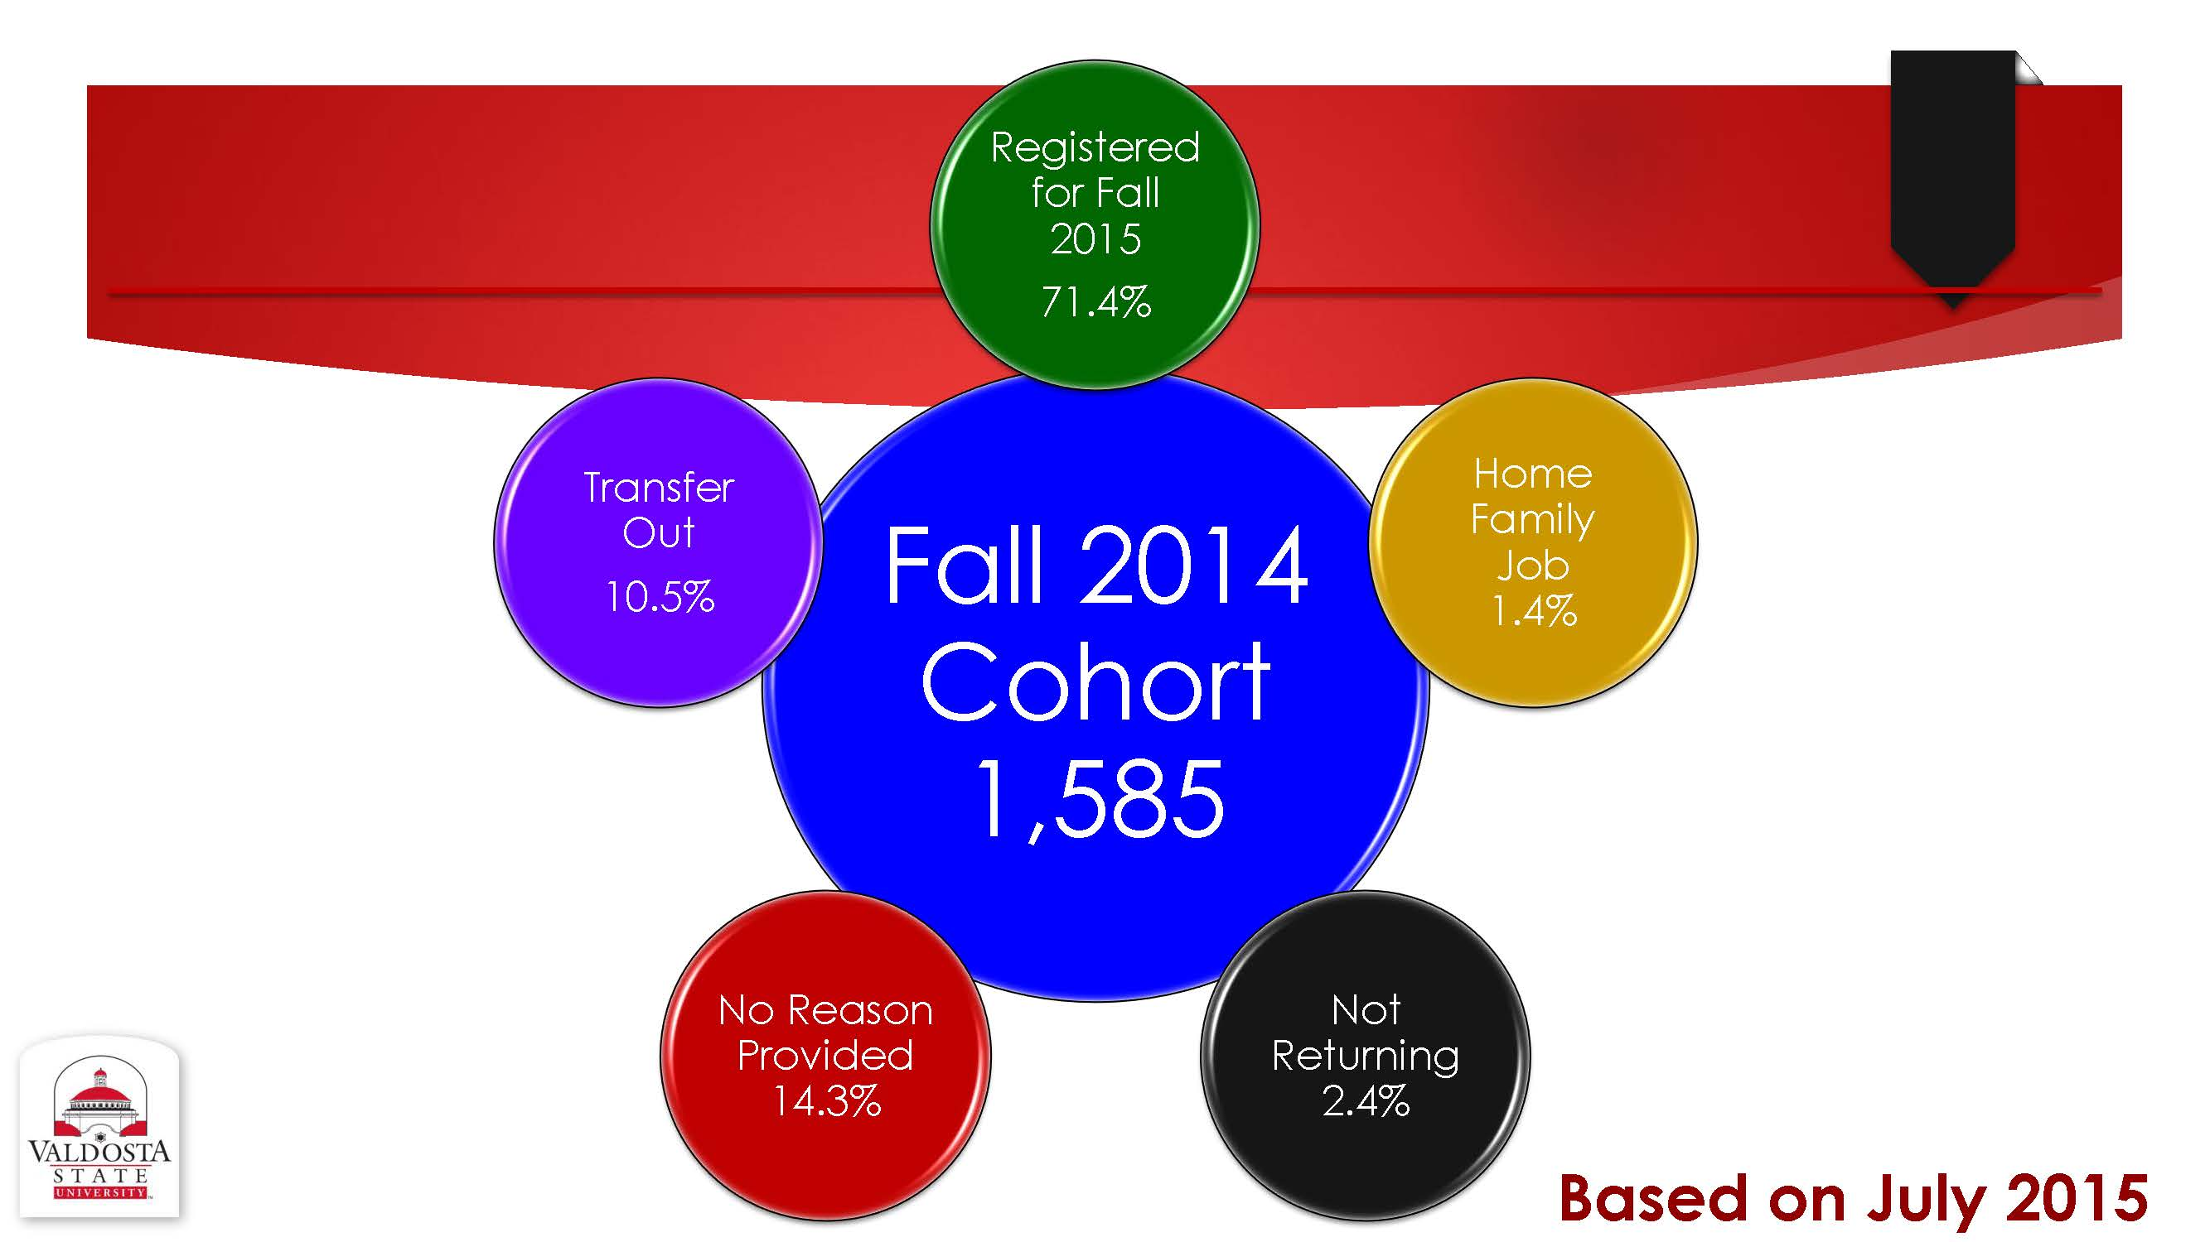

Exhibit B: National Retention Benchmarking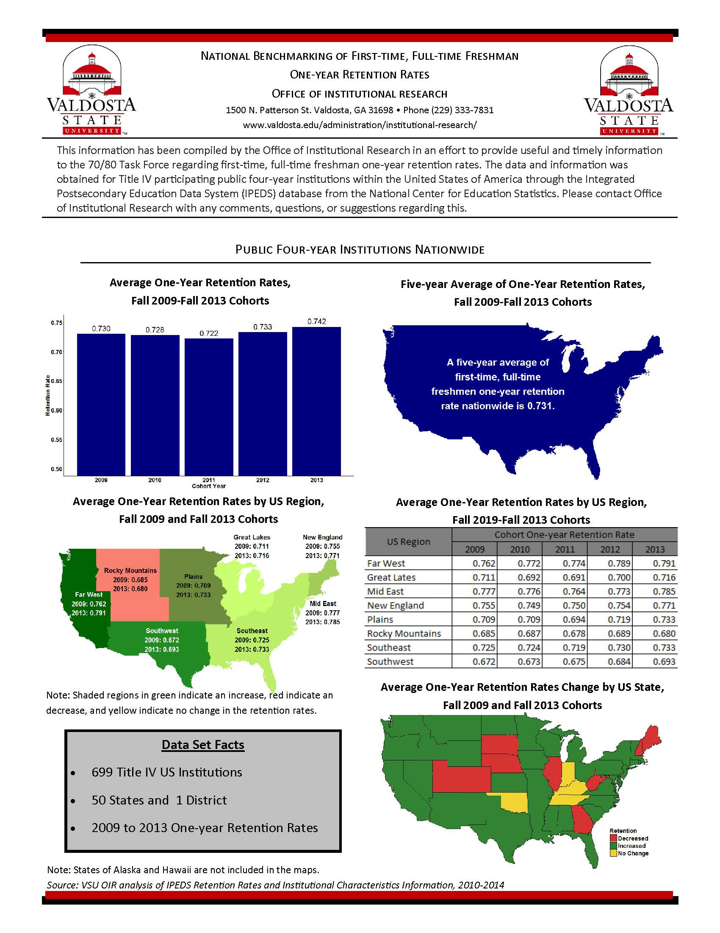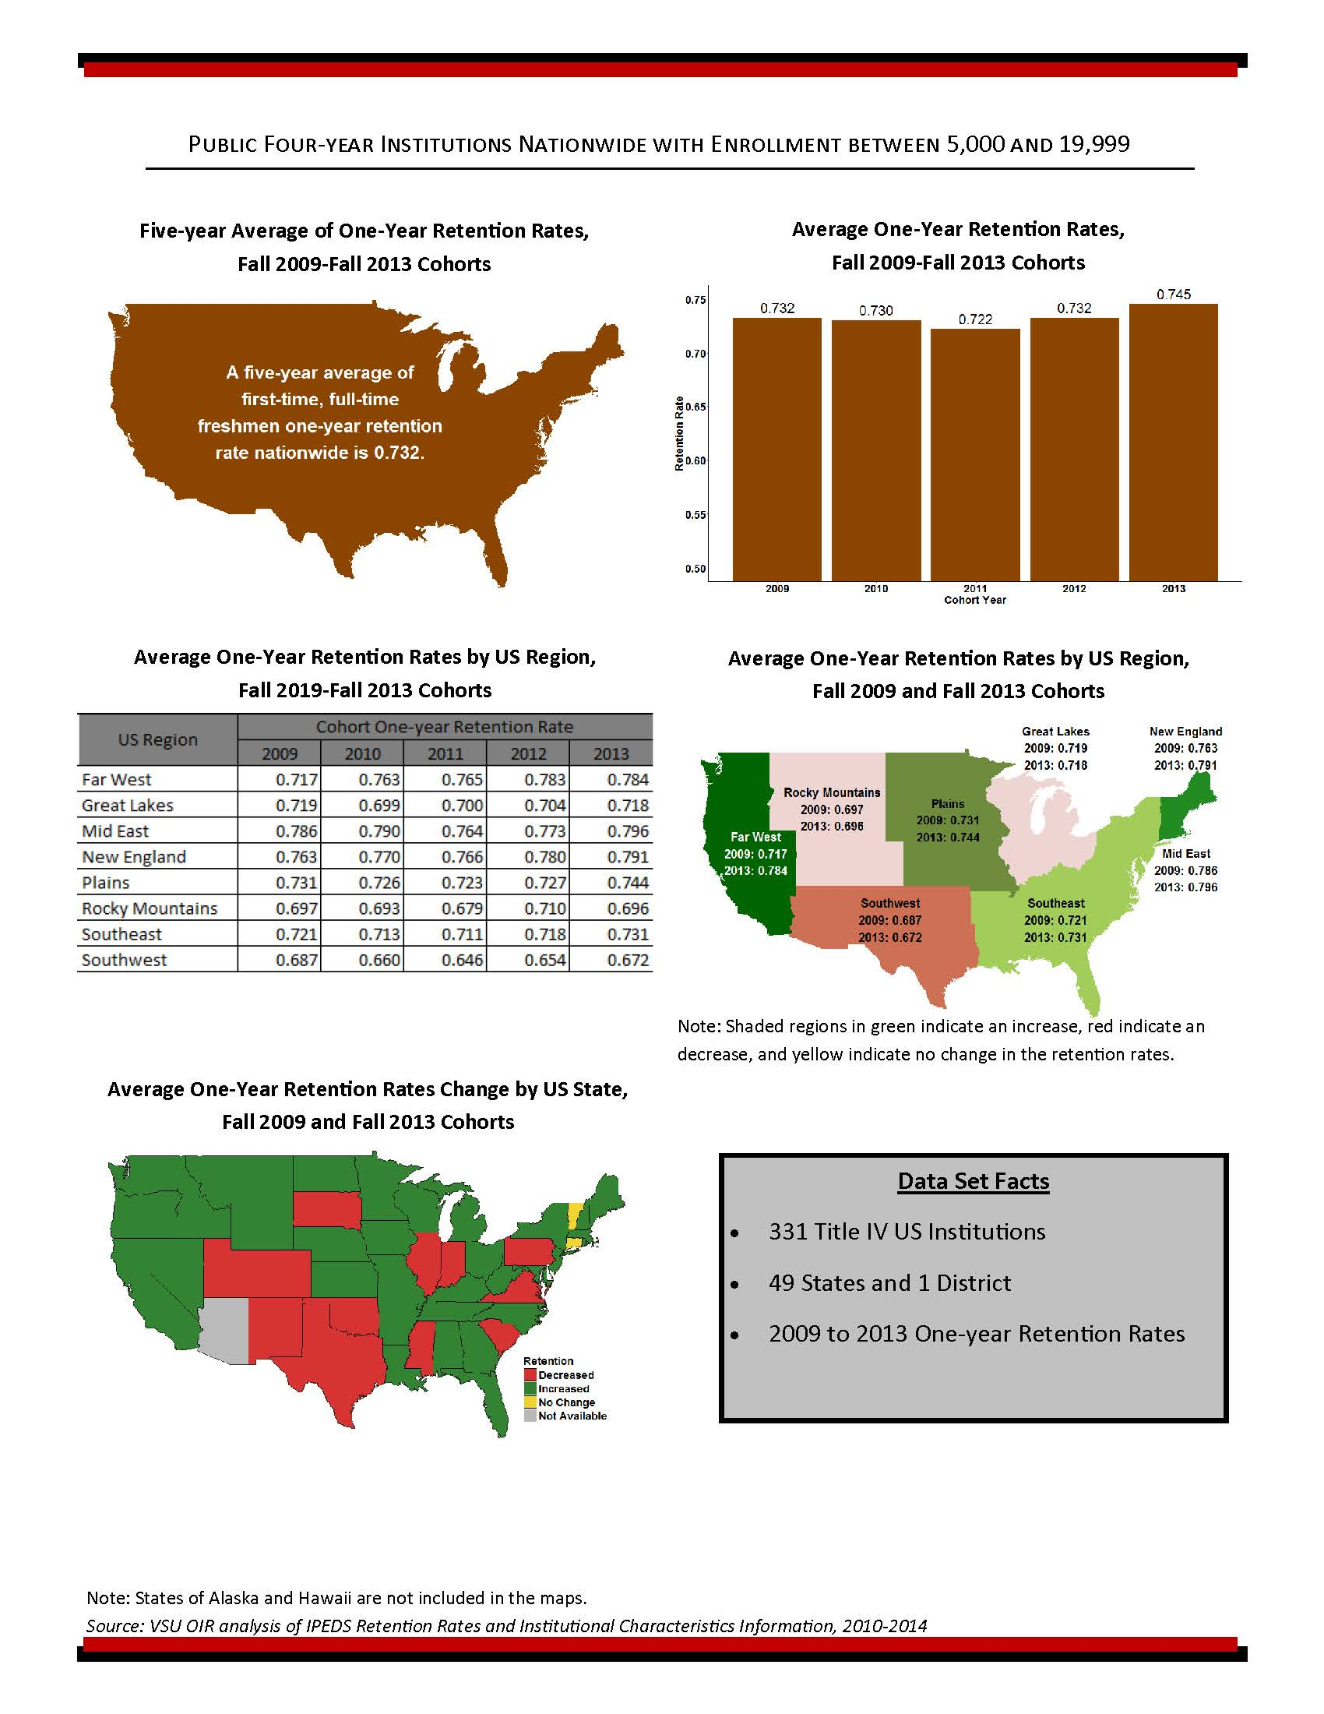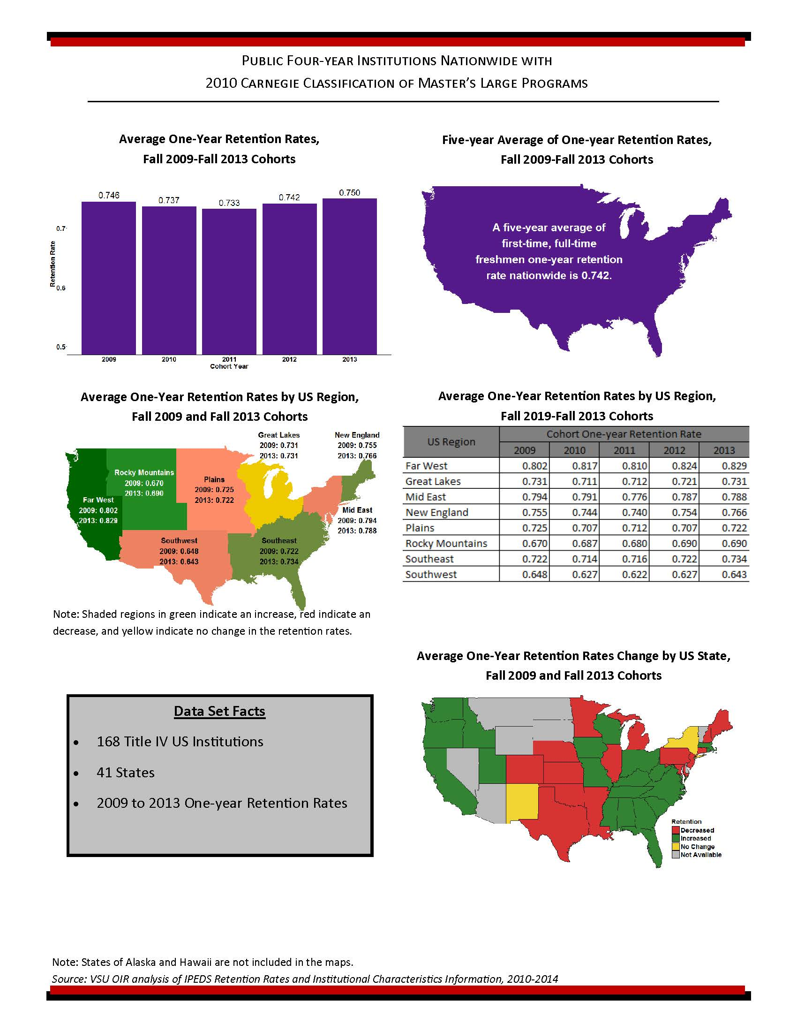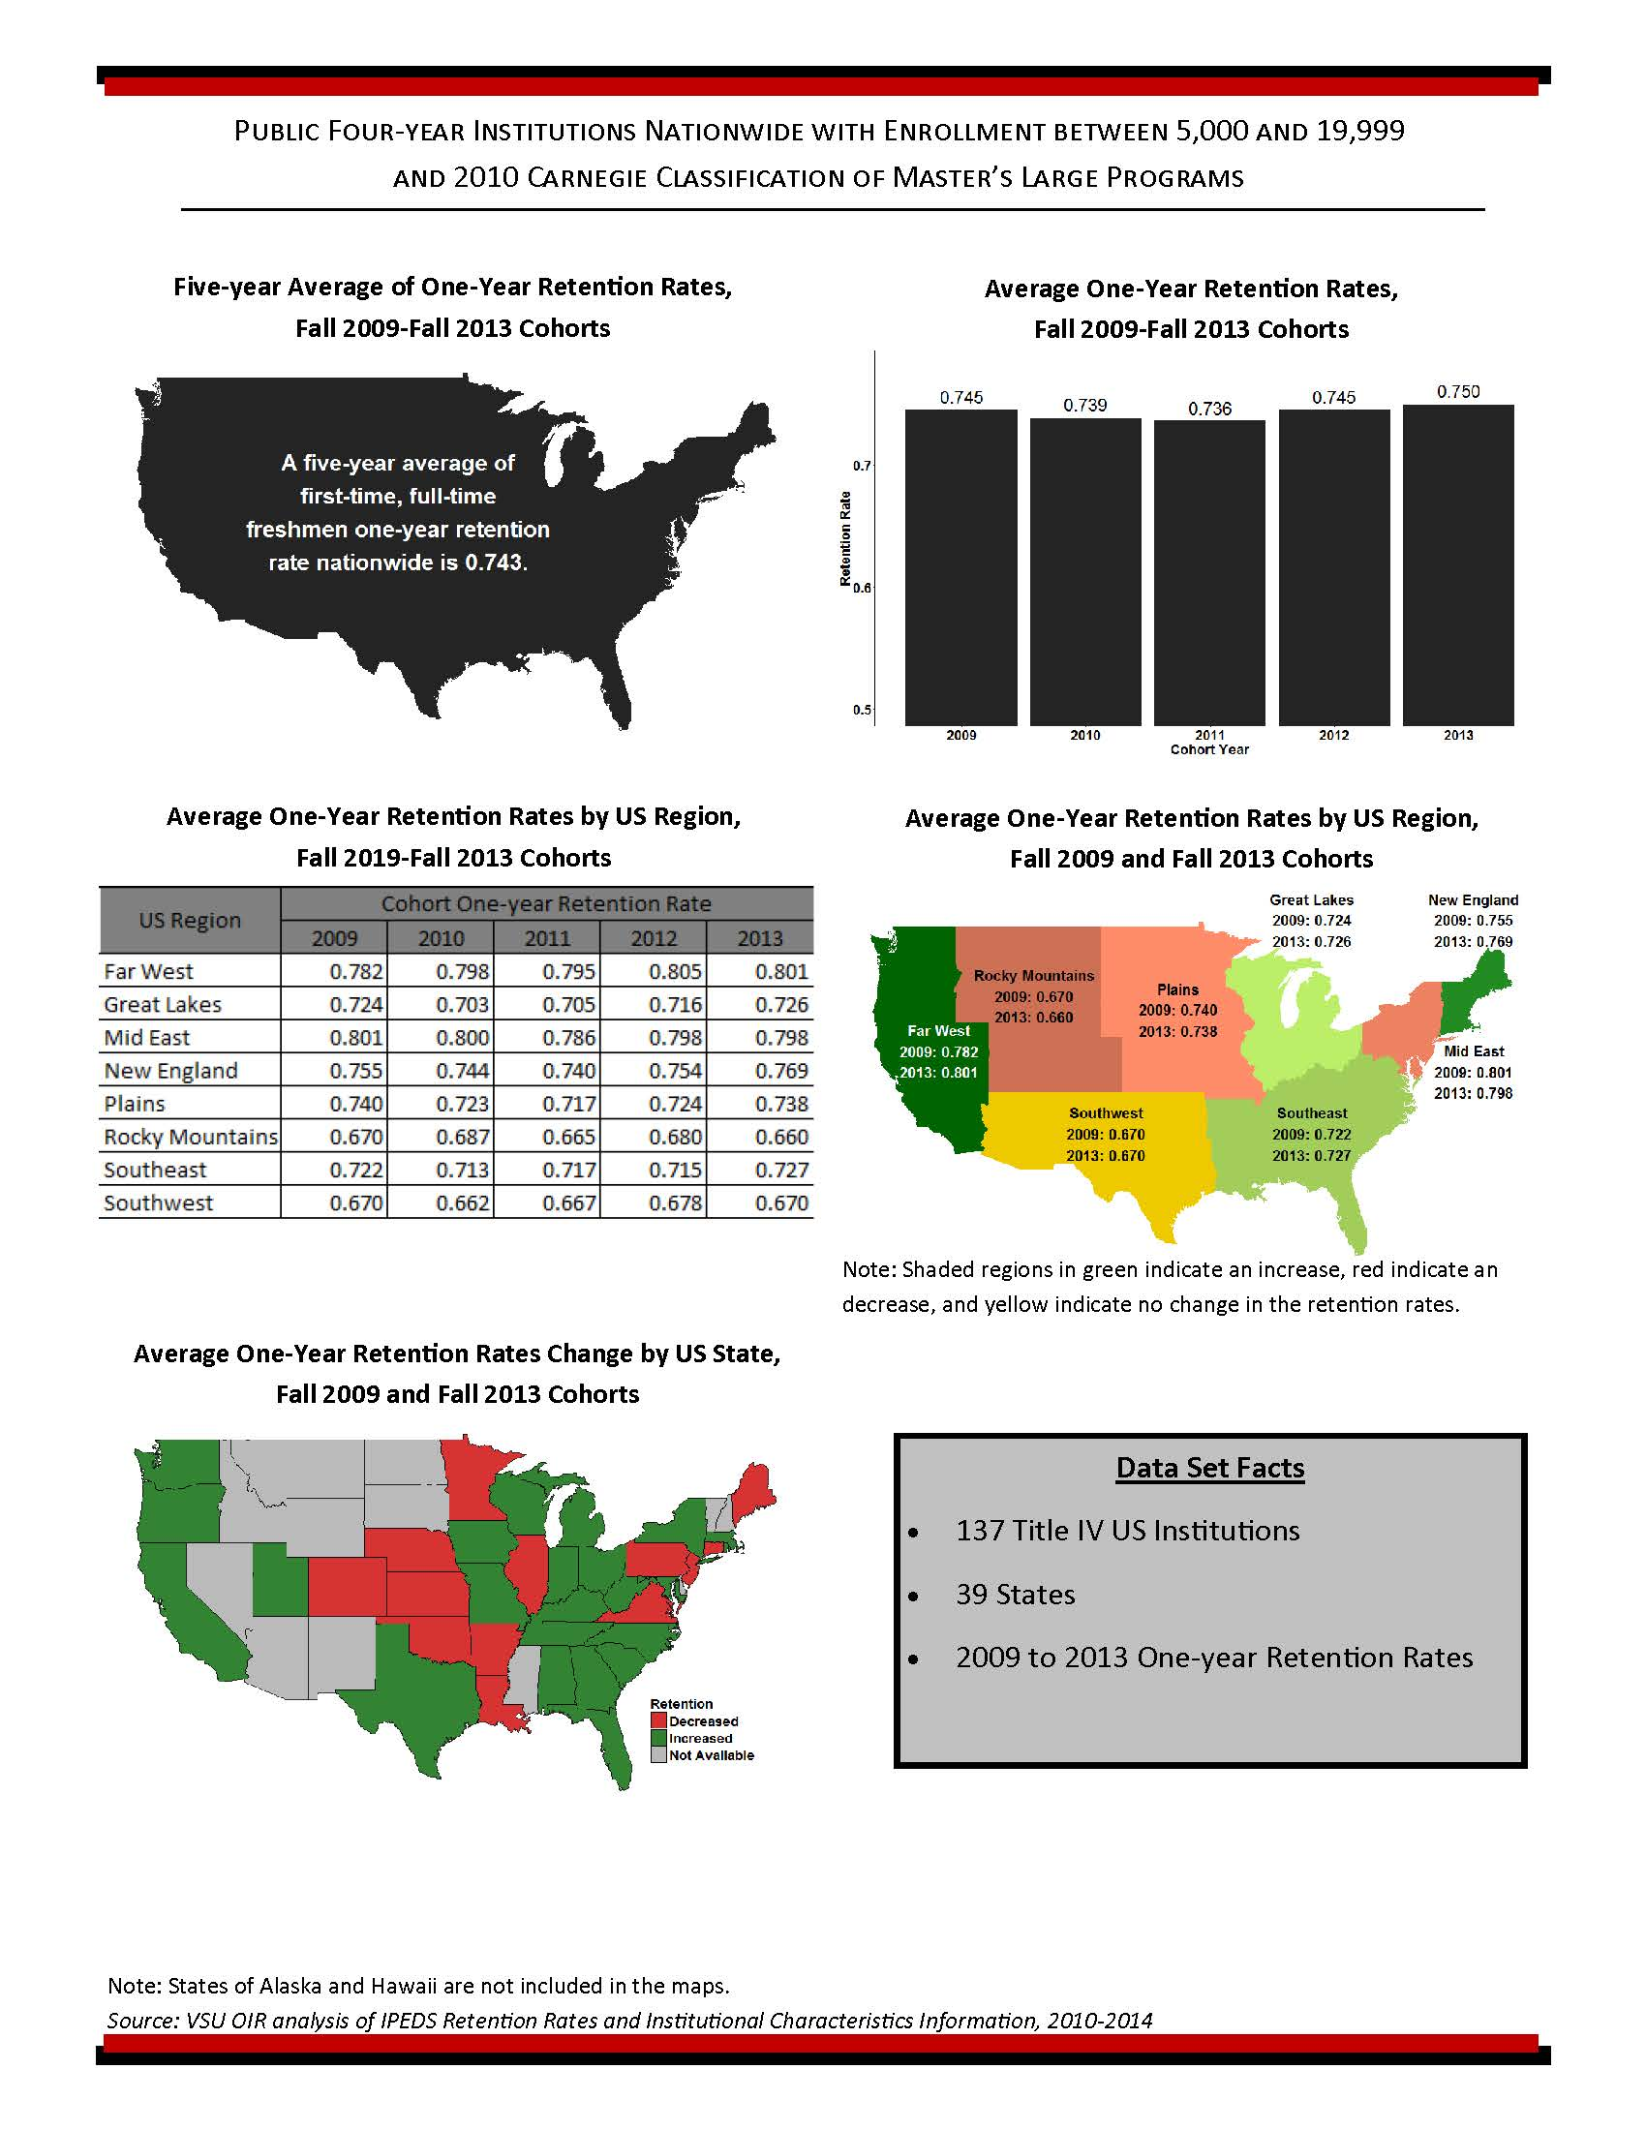

Exhibit C: USG Retention Benchmarking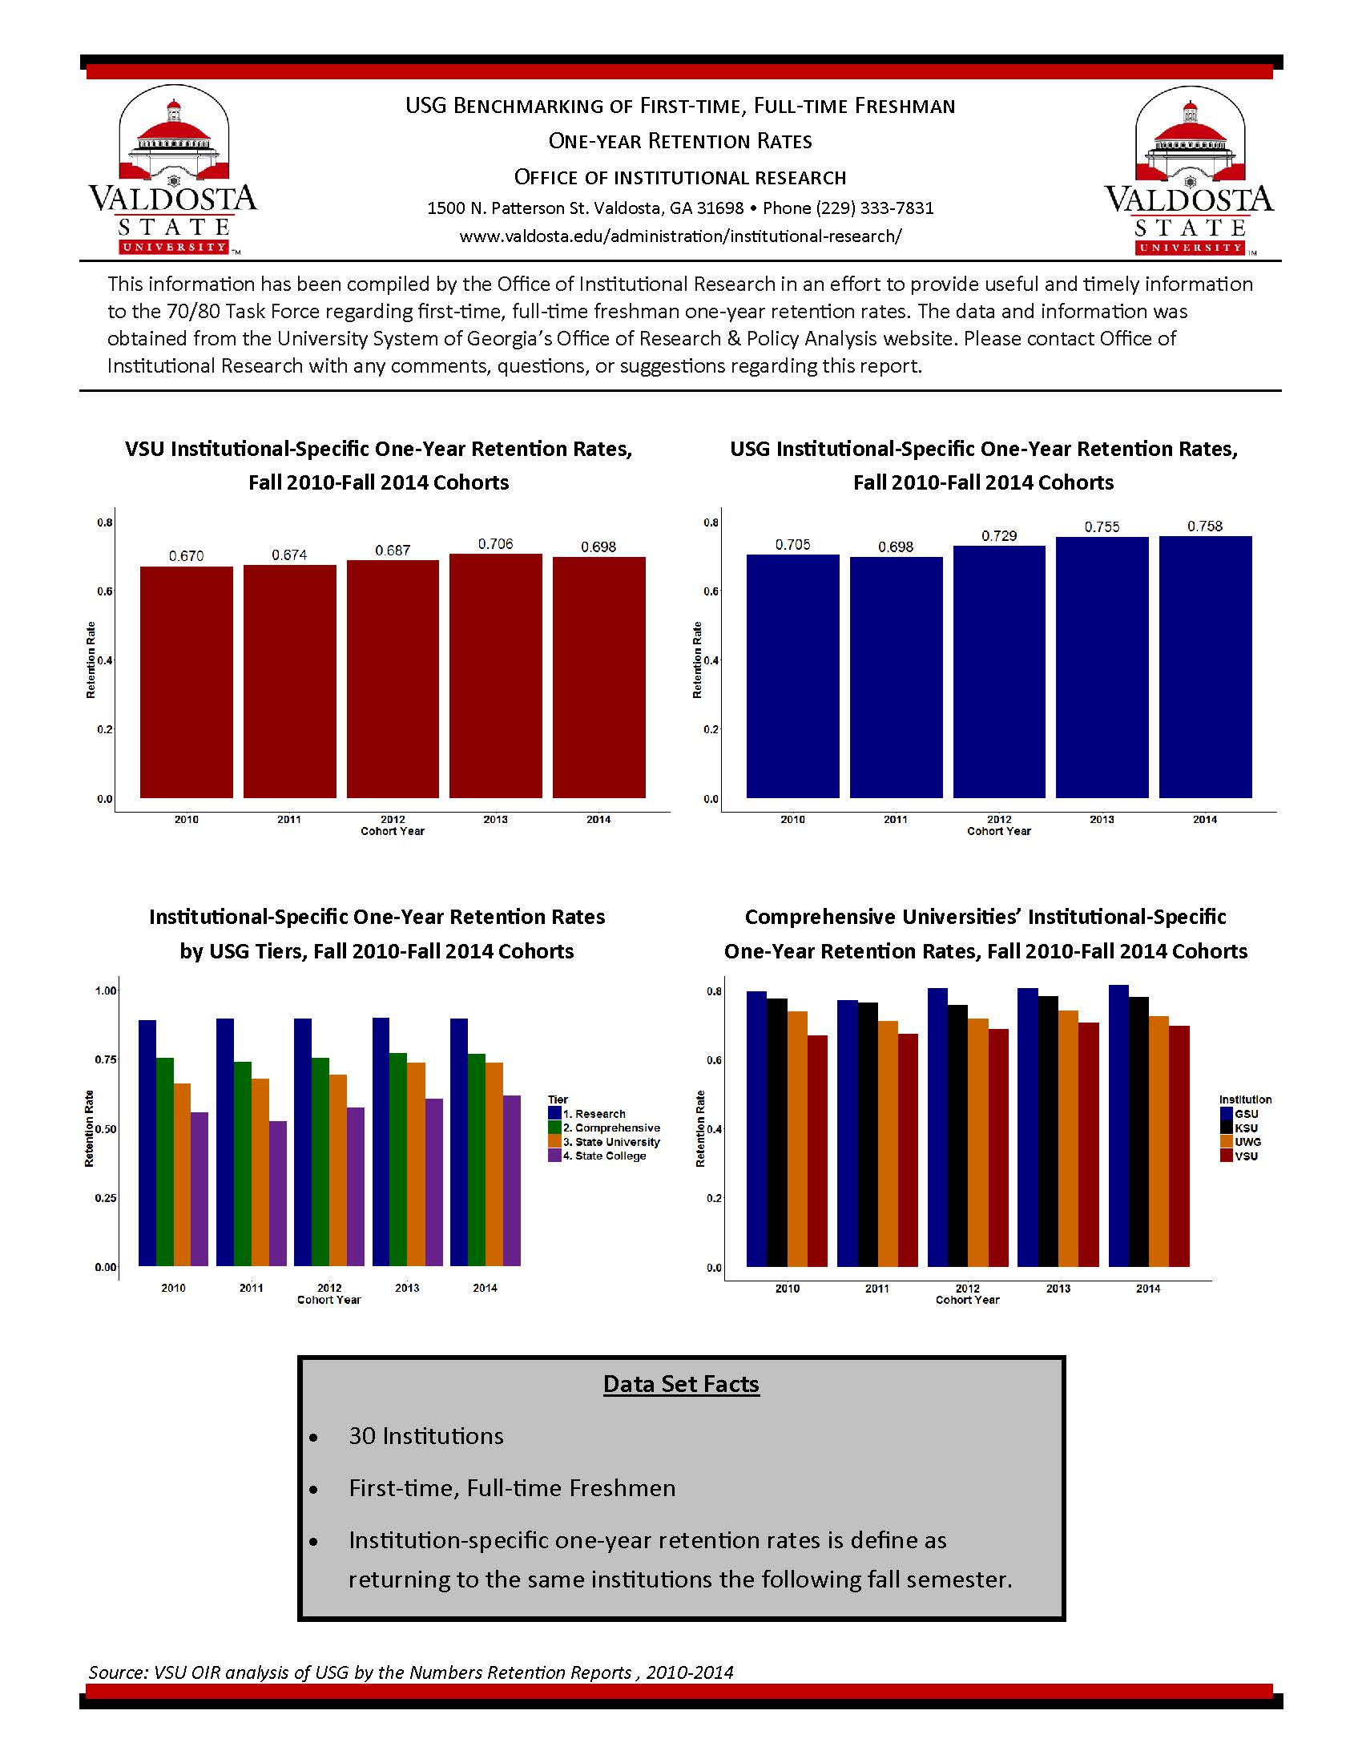
Exhibit D: VSU Retention Benchmarking