Editing an absence request for an employee
- Open the timesheet (Manager Self-Service Team Time Report Time) for the employee that needs the absence request edited
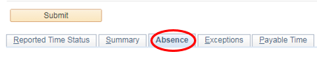
- Click the Absence tab below the Submit button

- Click the Edit button for the absence that needs to be changed

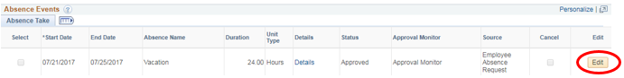

  - Click the Details link and the absence details window will open; enter the change that is needed for the absence. If the hours are incorrect, please make sure you are taking into account any partial days the employee is requesting and select this under the Partial Days drop-down menu. Click Calculate Duration to confirm the hours are correct.

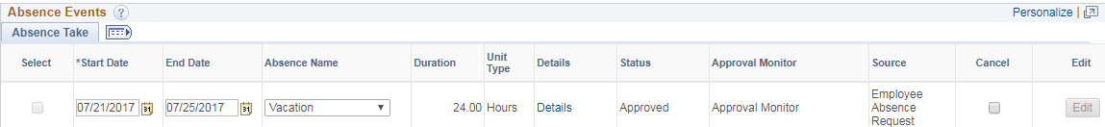

- Click OK to save the change
- Once you are taken back to the timesheet, Click the Submit button above the absence tab, click OK to confirm submission
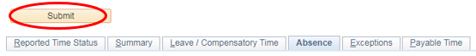

- Once back on the timesheet, the approval options should appear for you to approve the change under the Absence tab; select the row next to the absence that was changed and then click Approve
- If the approval options below are not available, please approve through the normal absence approval method (Manager Self-Service Team Time Absence Requests)
