Cancelling an absence request:
- Open the timesheet (Manager Self-Service Team Time Report Time) for the employee that needs the absence request cancelled
- Click the Absence tab below the Submit button
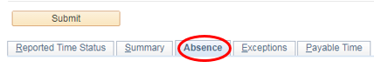

- Click the Edit button for the absence that needs to be changed
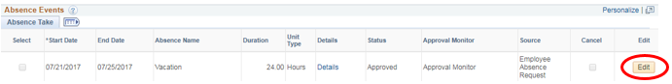

- Click the checkbox under the Cancel column
- Click Submit on the timesheet, click OK to confirm submission

- Once back on the timesheet, the approval options should appear for you to approve the change under the Absence tab; select the row next to the absence that was changed and then click Approve
- If the approval options below are not available, please approve through the normal absence approval method (Manager Self-Service Team Time Absence Requests)

