Submit an absence request on behalf of an employee
Method 1: Enter absence request from the timesheet
- Open the employee timesheet (Manager Self-Service Team Time Report Time)
- Search and select the appropriate employee
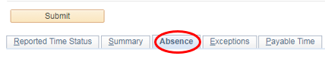
- Click the Absence tab below the Submit button

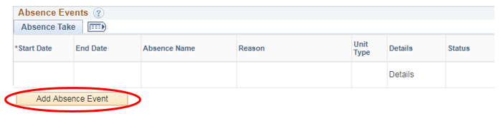
- Click the Add Absence Event button

- Select the Start Date, End Date & Absence Name
- Click the word Details under the Details column and the absence details window will open. If you are requesting a full day absence for all days click the Calculate Duration button, verify the total hours are correct, click OK. If you are requesting partial days, select the appropriate option using the Partial Days drop-down menu, click the Calculate Duration button, verify total hours are correct, then click OK.
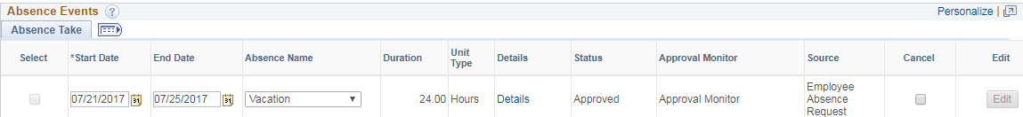

- Once you are taken back to the timesheet, Click the Submit button above the absence tab, click OK to confirm submission
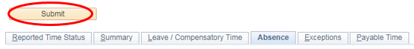

- Once back on the timesheet again, the approval options should appear for you to approve the request under the Absence tab; select the row next to the absence that was submitted and then click Approve
- If the approval options below are not available, please approve through the normal absence approval method (Manager Self-Service Team Time Absence Requests)
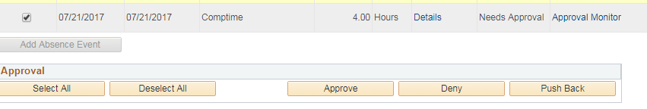
Method 2: Enter absence request from the portal
- Navigator Manager Self-Service Time Management Report Time Absence Request
- Click the Select button next to the employee that you needs the absence request submitted
- Enter the Start Date, select the Absence Name
- Enter the End Date, select the partial days option if needed, click the Calculate Duration button and verify the total hours are correct
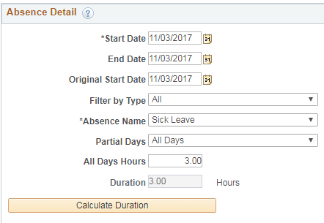
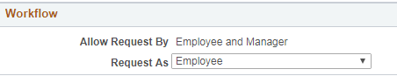
- Under the Workflow box, Request as Employee is selected by default – please keep this selection, do not change it
- Click the Submit button, click Yes to confirm submission
- Click OK to confirm the approval (this is telling you that it is already approved so no further action is needed)

